**BINARY TO DECIMAL CONVERSION**  
**EXP NO: 26**  
**AIM:**To write a C program to implement binary to decimal conversion.  
**ALGORITHM:**  
1)      Start  
2)      Read the binary number from the user, say ‘n’  
3)      Initialize the decimal number, d=0  
4)      Initialize i=0  
5)      Repeat while n != 0:                                                               
i.     Extract the last digit by: remainder = n % 10                                                             
ii.     n = n/10                                                           
iii.     d = d + (remainder * 2<sup>i</sup>)                                                           
iv.     Increment i by 1  
6)      Display the decimal number, d  
7)      Stop  
**PROGRAM:**  
  
  
#include  
<stdio.h>  
  
  
void  
main()   
  
  
{   
  
  
    int num, binary_num, decimal_num = 0, base  
= 1, rem;   
  
  
    printf (" Enter a binary number with  
the combination of 0s and 1s \n");   
  
  
    scanf (" %d", &num);  
  
  
    binary_num = num;  
  
  
    while ( num > 0)   
  
  
    {   
  
  
        rem = num % 10;  
  
  
        decimal_num = decimal_num + rem *  
base;   
  
  
        num = num / 10;   
  
  
        base = base * 2;   
  
  
    }   
  
  
   
  
  
    printf ( " The binary number is %d  
\t", binary_num);  
  
  
    printf (" \n The decimal number is %d  
\t", decimal_num);     
  
  
}  
  
  
   
  
  
   
  
  
  
  
  
**INPUT:**  
  
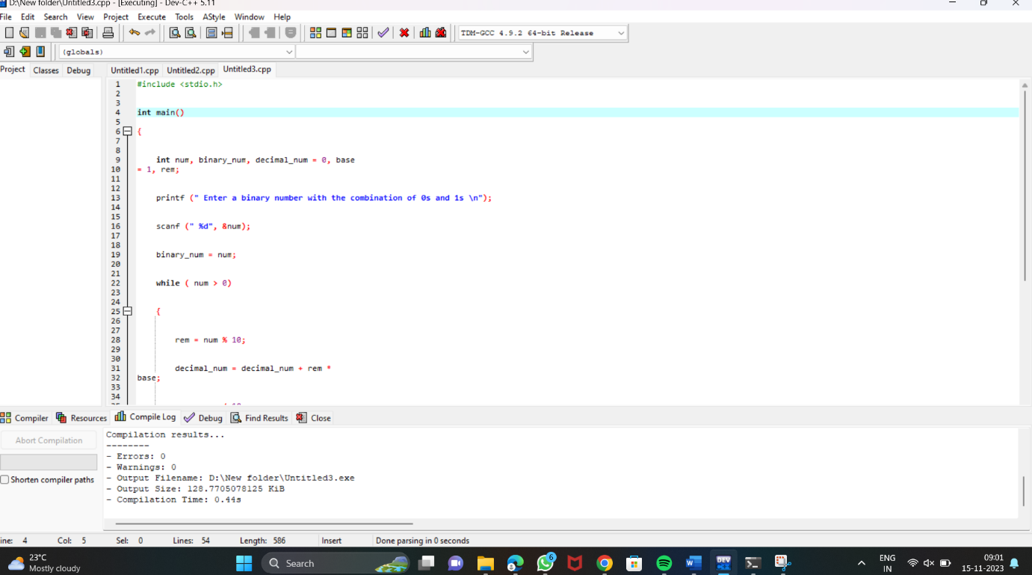  
  
  
  
  
  
  
  
  
  
  
  
  
  
  
  
**OUTPUT:**  
  
  
 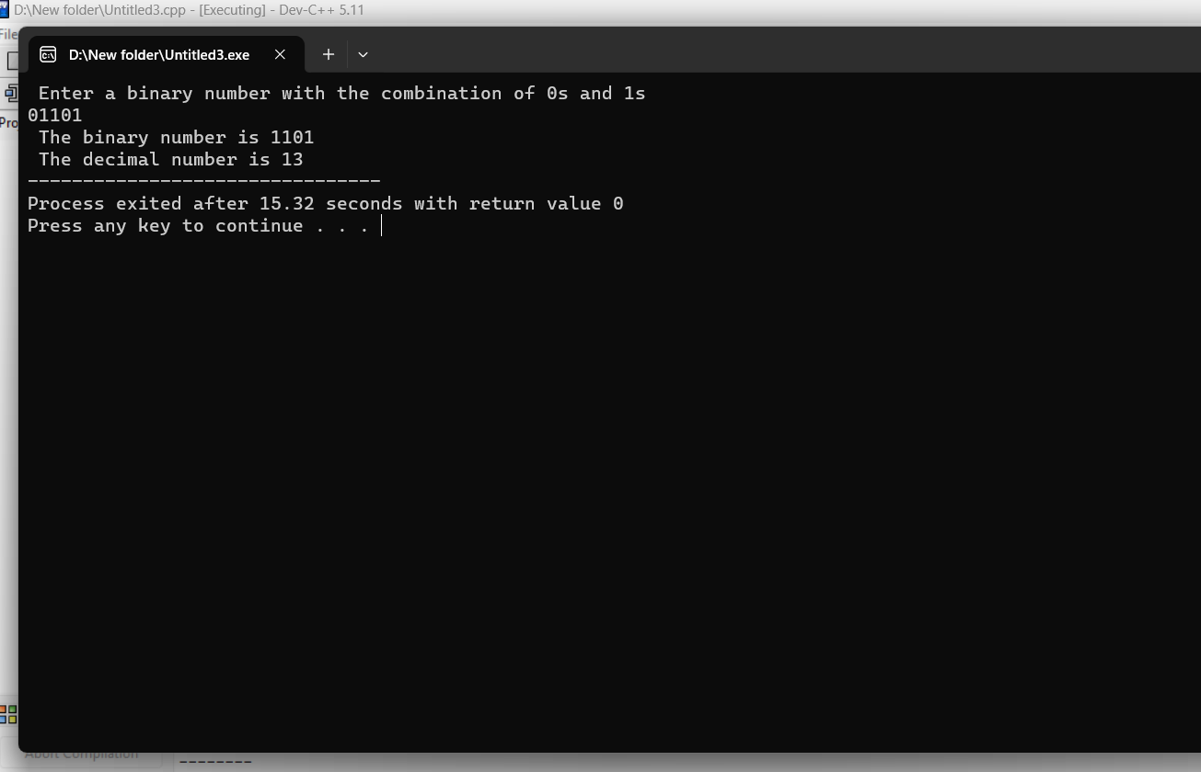  
  
  
   
  
  
   
  
  
   
  
  
  
  
  
  
  
  
  
  
  
  
  
  
  
  
  
  
**RESULT:**Thus the program was executed successfully using DevC++.